Masimo Cables – Philips & Corpuls
- Cables to connect to third party monitors, Philips and Corpuls
4076: RD rainbow SET, 25R-5, 5 ft  4106: RD rainbow SET, 25R-8, 8 ft  4078: RD rainbow SET, 25R-12, 12 ft  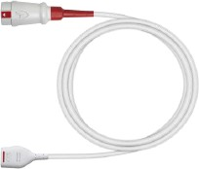 | Philips RD 25RA 25-pin Right Angle, compatible with AO5  Phillips & Corpuls monitors  4075: RD rainbow, 25RA-1.5, 1.5 ft.  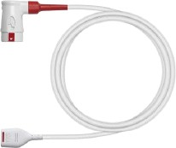  4077: RD rainbow, 25RA-5, 5 ft.  4107: RD rainbow, 25RA-8, 8 ft.
Philips LNCS 25R 25-pin, compatible with AO5 Phillips & Corpuls monitors  3935: LNCS® Red Patient Cable, Red 25 LNC-1, LNCS® Series 25-pin Patient Cable, 1 ft., for Corpuls monitors  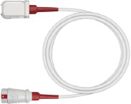  3630: LNCS, Red 25 LNC-4, 25-pin, 4 ft  3345: Red 25 LNC-10RA, 10 ft | Philips LNCS 25RA 25-pin Right Angle, compatible with  AO5 Phillips & Corpuls monitors  3376: Red 25 LNC-4RA, 4 ft  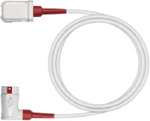  3345: Red 25 LNC-10RA, 10 ft
Philips – RD-MP compatible with Philips IntelliVue or Philips FAST (AO3 modules)  4082: RD Dual Key Patient Cable, MP-05, 5 ft  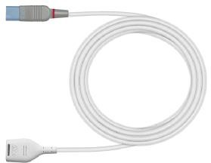  4083: RD Dual Key Patient Cable, MP-12, 12 ft | Philips – LNCS-MP compatible with Philips IntelliVue or Philips FAST (AO3 modules)  2281: LNCS Dual Key Patient Cable, MP10, 10 ft.  

